**Case Study : Tuberculosis Trends – Global and Regional Insights**

**Introduction**

Welcome to the Tuberculosis Trends – Global and Regional Insights case study. We will be dealing with finding the trends of the Tuberculosis disease and what are the social and economic factors what affect the growth, spread and treatment of this disease.

**About Tuberculosis**

Tuberculosis (TB) is an infectious disease caused by bacteria that most often affects the lungs. It spreads through the air when people with TB cough, sneeze or spit.

Tuberculosis is preventable and curable.

About a quarter of the global population is estimated to have been infected with TB bacteria. About 5–10% of people infected with TB will eventually get symptoms and develop TB disease.

Those who are infected but free of disease cannot transmit it. TB disease is usually treated with antibiotics and can be fatal without treatment.

In certain countries, the Bacille Calmette-Guérin (BCG) vaccine is given to babies or small children to prevent TB. The vaccine prevents deaths from TB and protects children from serious forms of TB.

Certain conditions can increase a person’s risk for TB disease:

* diabetes (high blood sugar)
* weakened immune system (for example, from HIV or AIDS)
* being malnourished
* tobacco use
* harmful use of alcohol.

**Symptoms**

People with TB infection don’t feel sick and aren’t contagious. Only a small proportion of people who get infected with TB will get TB disease and symptoms. Babies and children are at higher risk.

TB disease occurs when bacteria multiply in the body and affect different organs. TB symptoms may be mild for many months, so it is easy to spread TB to others without knowing it. Some people with TB disease do not have any symptoms.

Common symptoms of TB are:

* prolonged cough (sometimes with blood)
* chest pain
* weakness
* fatigue
* weight loss
* fever
* night sweats

The symptoms people get depend on which part of the body is affected by TB. While TB usually affectsthe lungs, it can also involve the kidneys, brain, spine and skin.

**Source:** [World Health Organization](https://www.who.int/news-room/fact-sheets/detail/tuberculosis#:~:text=Tuberculosis%20(TB)%20is%20an%20infectious,been%20infected%20with%20TB%20bacteria.)

**Problem Statement**

**Key Objectives:**

* Analyse the impact of income level, GDP per capita, and health expenditure on TB cases and deaths.
* Study the role of healthcare access indicators (doctors per 100K, hospitals per million, access to health services) on TB outcomes.
* Explore the effects of lifestyle factors (smoking prevalence, malnutrition) on TB incidence and mortality.
* Examine the association between HIV co-infection rates and TB mortality.
* Provide actionable insights for policymakers to target interventions more effectively.

**Dataset**

The dataset used for this analysis was downloaded from ourdatainworld.com, with the data sourced from the World Health Organization (WHO). All data—except for age-specific and risk factor attribution—is from the years 2000 to 2021; the age and risk factor data pertain to the year 2022 only. I do not own this data; all rights and attributions remain with the original data providers.

The relevant licenses are included in the GitHub repository shared by the data publishers. However, for the purpose of this analysis, I have also derived new variables and created extended datasets based on the original data to support deeper insights and customized analysis.

Here is the link to the dataset: [Dataset](https://github.com/akshatsingh2002/TB_CASE_STUDY)

**Column Definitions:**  
The dataset contains multiple variables critical for understanding Tuberculosis (TB) dynamics globally.

**Column Definitions**

* **country:** Name of the country where the data is recorded.
* **year:** The year for which the data is reported.
* **country_code:** ISO 3-letter country code (e.g., IND for India).
* **gdp_per_capita:** Gross Domestic Product per capita, representing the average economic output per person (in USD).
* **tb_new_cases:** Estimated number of new tuberculosis (TB) cases in a given year.
* **tb_deaths:** Estimated number of deaths from all forms of tuberculosis.
* **health_exp_gdp**: Public health expenditure of the country's.
* **treatment_success_rate**: Success rate of treatment for new and relapse TB cases.

**Age-Specific TB Case Data**

* **age_0_4_cases:** Estimated TB cases among children aged 0–4 years.
* **age_5_14_cases:** Estimated TB cases among individuals aged 5–14 years.
* **age_15_24_cases:** Estimated TB cases among individuals aged 15–24 years.
* **age_25_34_cases:** Estimated TB cases among individuals aged 25–34 years.
* **age_35_44_cases:** Estimated TB cases among individuals aged 35–44 years.
* **age_45_54_cases:** Estimated TB cases among individuals aged 45–54 years.
* **age_55_64_cases:** Estimated TB cases among individuals aged 55–64 years.
* **age_65_plus_cases:** Estimated TB cases among individuals aged 65 years and **older.**

**TB Incidence Attributed to Risk Factors**

* **tb_due_to_hiv:** Estimated TB incidence attributed to HIV infection in males and females.
* **tb_due_to_alcohol:** Estimated TB incidence attributed to harmful alcohol use in individuals aged over 15 years.
* **tb_due_to_smoking:** Estimated TB incidence attributed to smoking in individuals aged over 15 years.
* **tb_due_to_diabetes:** Estimated TB incidence attributed to diabetes in individuals aged over 18 years.
* **tb_due_to_undernourishment:** Estimated TB incidence attributed to undernourishment in males and females.

**Analysis**

**Overview**

This study explores the global distribution, mortality, treatment outcomes, and contributing factors of tuberculosis (TB), with a focus on country-level differences, regional disparities, and the influence of age and risk factors. The analysis spans data primarily from **2000 to 2021**, with **age and risk factor data** from **2022**.

**1. Global TB Burden by Country and Region**

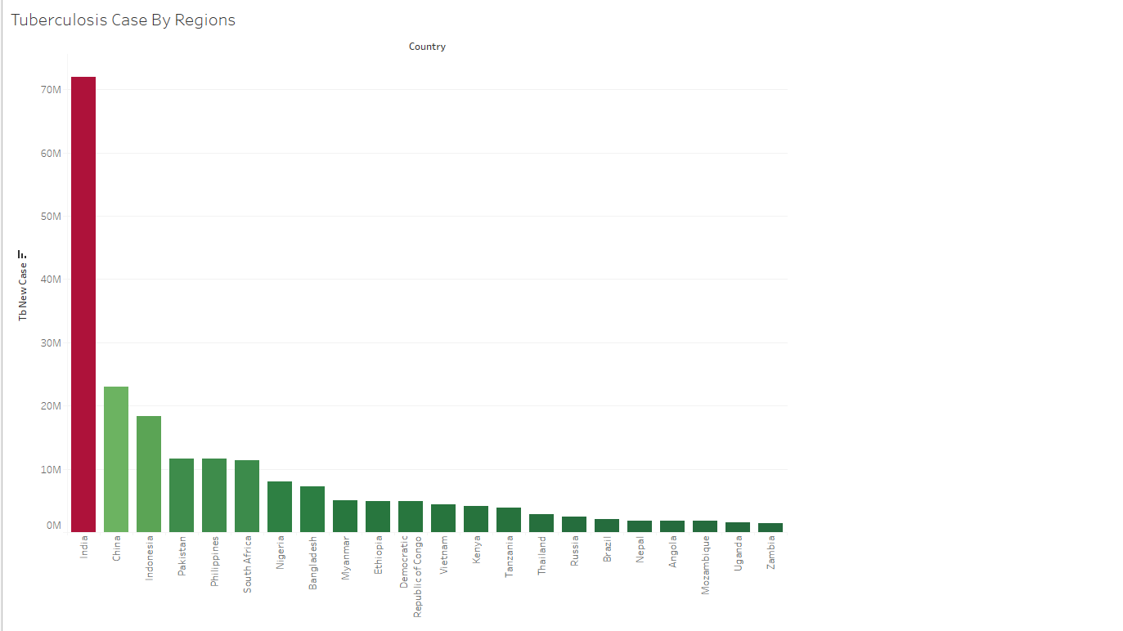

Among the **top 20 countries** with the highest number of TB cases, **11 are from Asia**, and the **remaining are from Africa**.

* **India** leads with **7,197,000 cases**, followed by **China** with **2,294,600**, and **Indonesia**.
* This trend highlights the link between **developing economies**, **high population density**, and **TB prevalence**.

This distribution emphasizes how **socioeconomic development and healthcare infrastructure** significantly influence TB case numbers.

**2. Mortality Rate Trends**

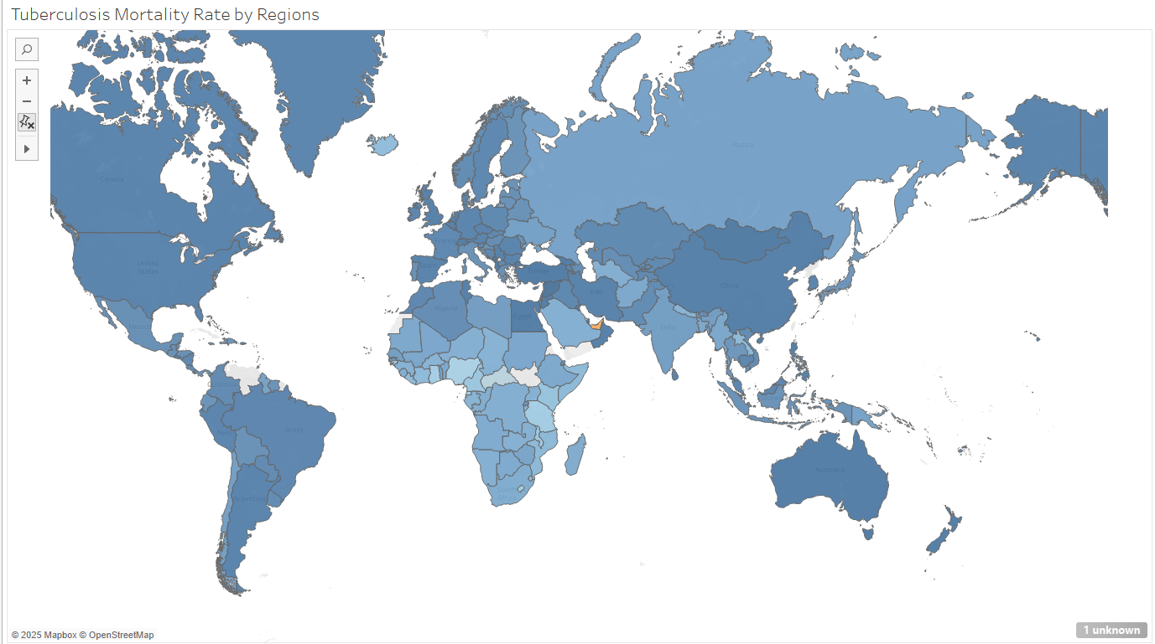

A similar pattern is observed in **mortality rates**:

* **Developing nations** such as **India**, **Afghanistan**, **Myanmar**, and **Indonesia** report higher TB mortality rates.
* Notably, **China** demonstrates **very low mortality**, despite its high number of cases, indicating better healthcare access and treatment systems.
* **Russia**, although considered developed, shows **elevated mortality rates** compared to its European and American counterparts.

**Regional Improvement Over Time**

* Comparing **mortality rates between 2000–2010 and 2011–2021**, significant improvement is evident in the **African region**, suggesting the positive impact of public health interventions and international support.

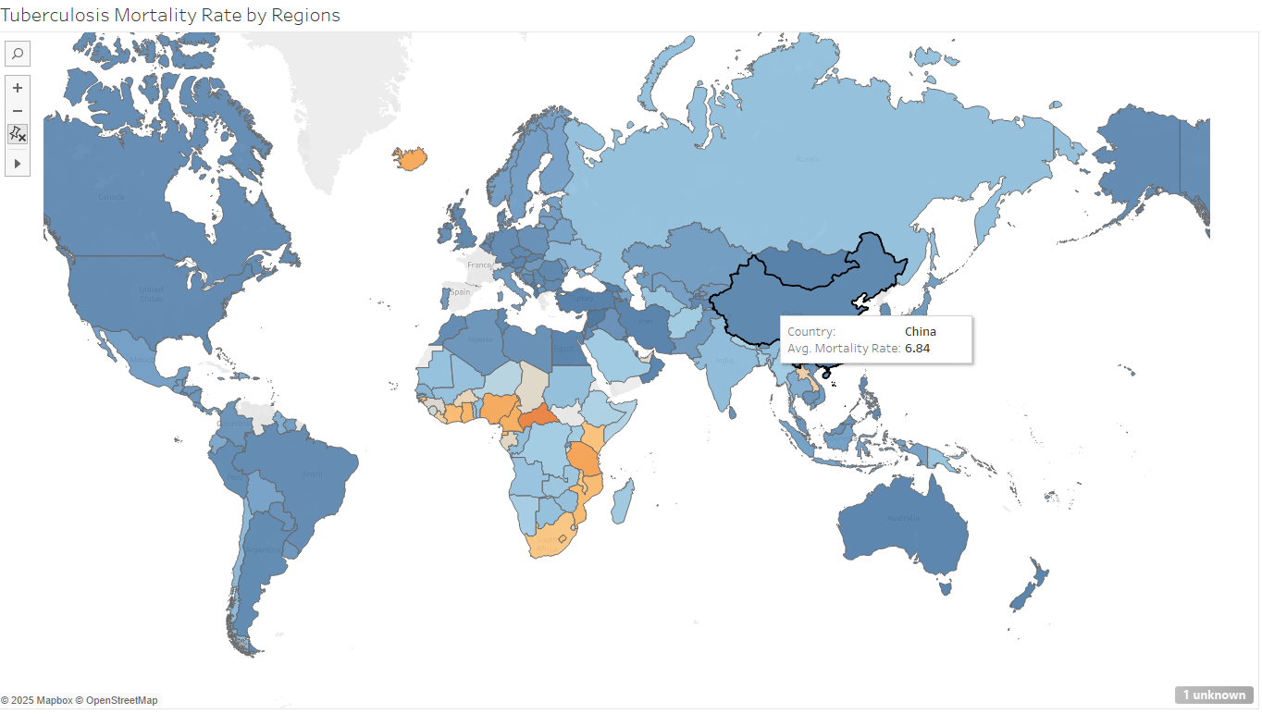

**3. Treatment Success Rate Analysis**

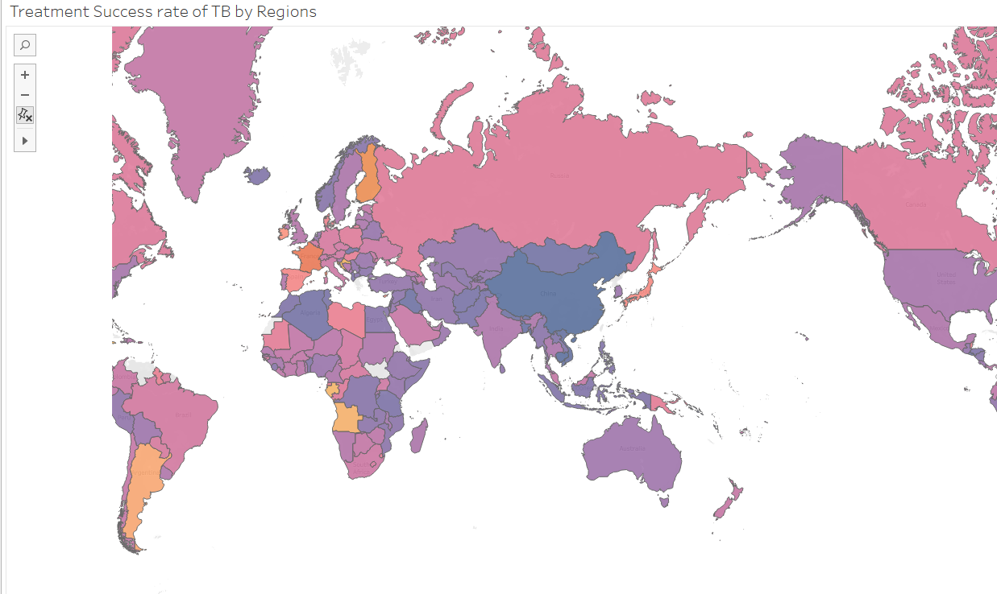

Analysis of **treatment success rates** reveals:

* **Asian countries** show **higher treatment success rates** overall, likely due to expanding healthcare services and population-level access to care.
* **China** stands out with consistently high success, while **India** shows dramatic improvement—from **34% in 2000** to **78% in 2021**.
* However, **Argentina** and **Angola** report **lower-than-average success rates**, despite having full datasets available from **2000 to 2021**.
* In contrast, **European countries** report lower success rates partly due to **missing or incomplete data**.

**4. TB Mortality Attributed to Age (2022 Data)**

An age-wise analysis of TB mortality for the year 2022 highlights stark differences across countries and regions. This data provides critical insight into which age groups are most at risk in specific geographies, reflecting disparities in health infrastructure, co-morbidities, and access to early diagnosis and treatment.

* **Ages 0–4:**  
  The highest number of TB-related deaths in this age group occurred in **Indonesia**. This reflects both the high population of children and the challenges in early TB detection and treatment in younger age groups. The result may also point to gaps in paediatric healthcare coverage and TB prevention programs.

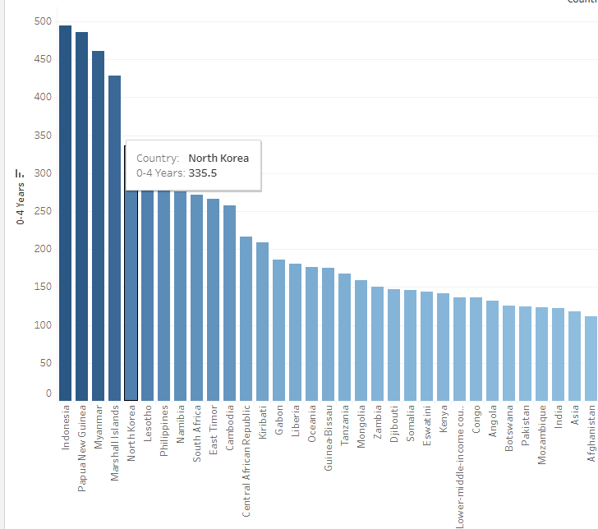

* **Ages 4–15:**  
  **Papua New Guinea** recorded the highest TB mortality in this age group. This pattern likely stems from limited access to quality healthcare in remote areas, underdiagnosis, and socio-economic challenges that affect child health and nutrition.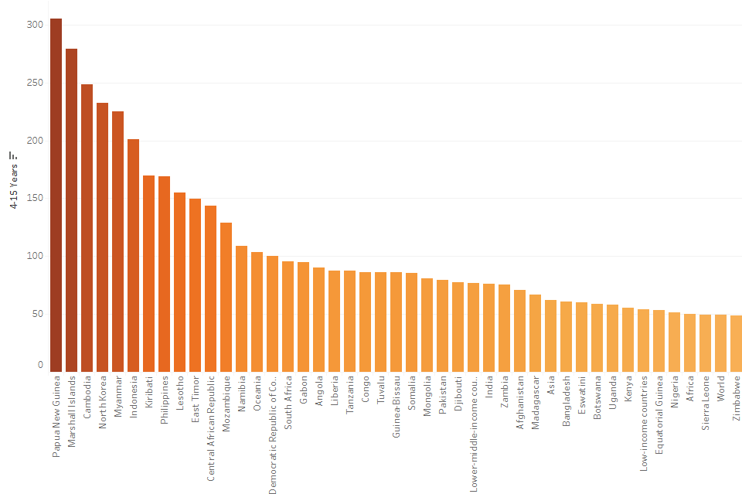
* **Ages 15–24:**  
  **Mongolia** showed the highest number of TB deaths among young adults. In this age group, lifestyle factors such as tobacco use, combined with undernutrition and access issues, may be contributing factors.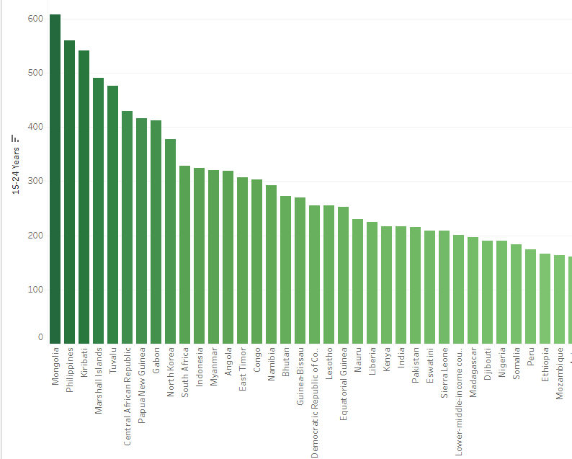
* **Ages 25–34:**  
  The **Central African Republic (CAR)** had the highest mortality in this group. This continues a trend seen in several age brackets and is likely driven by conflict-related healthcare breakdowns, poor access to TB care, and high rates of HIV co-infection.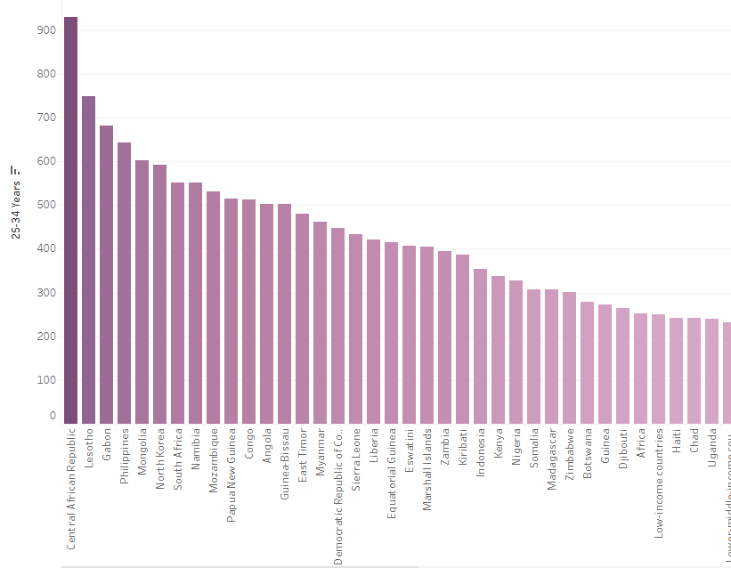
* **Ages 35–44 and 45–54:**  
  **CAR** maintained the highest mortality figures in these age groups as well. The continued dominance suggests chronic healthcare challenges in the country, limited TB control efforts, and ongoing barriers to treatment adherence and diagnosis.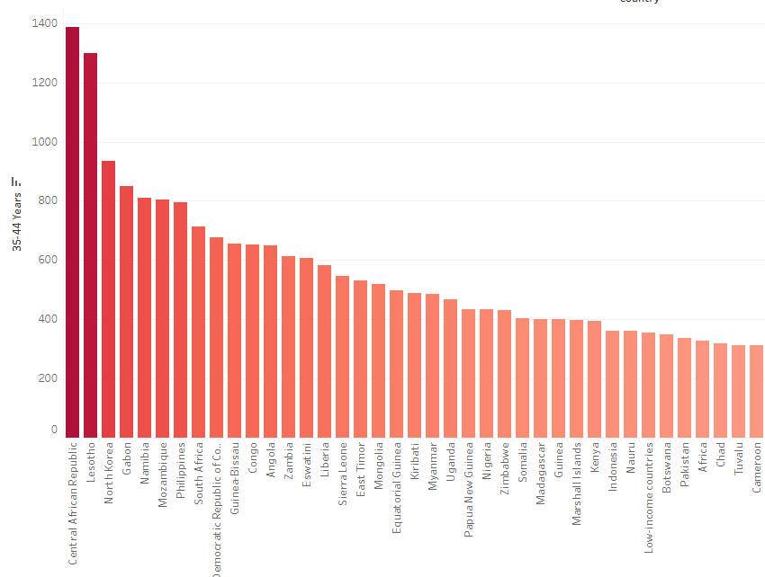

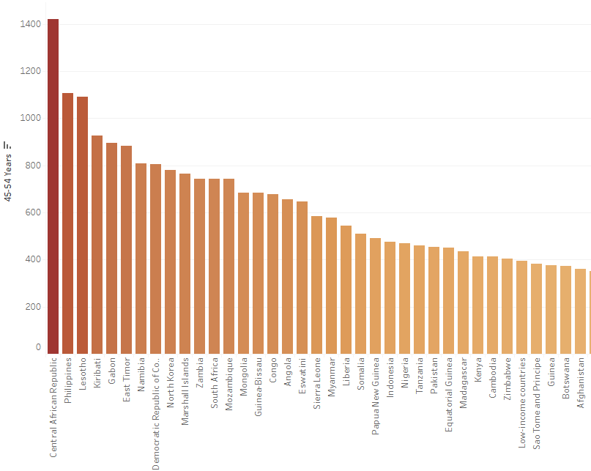

* **Ages 55–64:**  
  In this older age group, **Timor-Leste** reported the most TB-related deaths. This may be linked to a lack of specialized care for aging populations, late-stage diagnoses, and underfunded public health systems.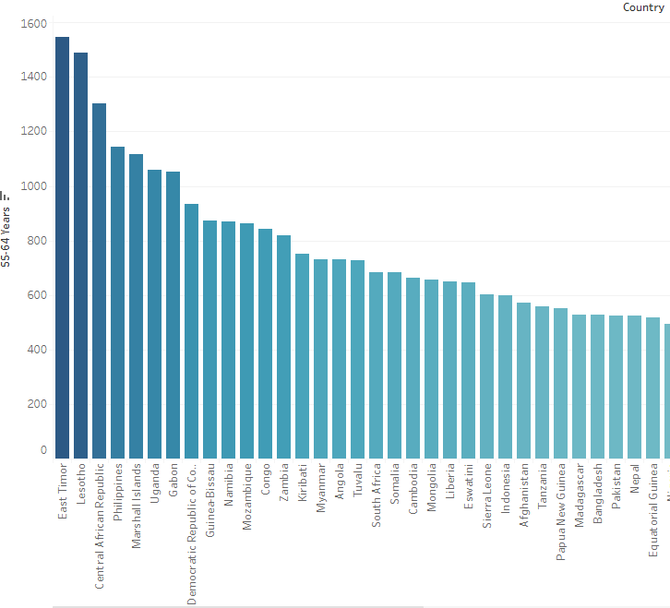
* **Ages 65 and above:**  
  **Lesotho** recorded the highest mortality among the elderly, followed by **Timor-Leste** and **CAR**. Lesotho’s high HIV prevalence plays a key role in driving TB mortality in this group, while the other two countries face similar health system limitations in managing chronic and age-related TB risks.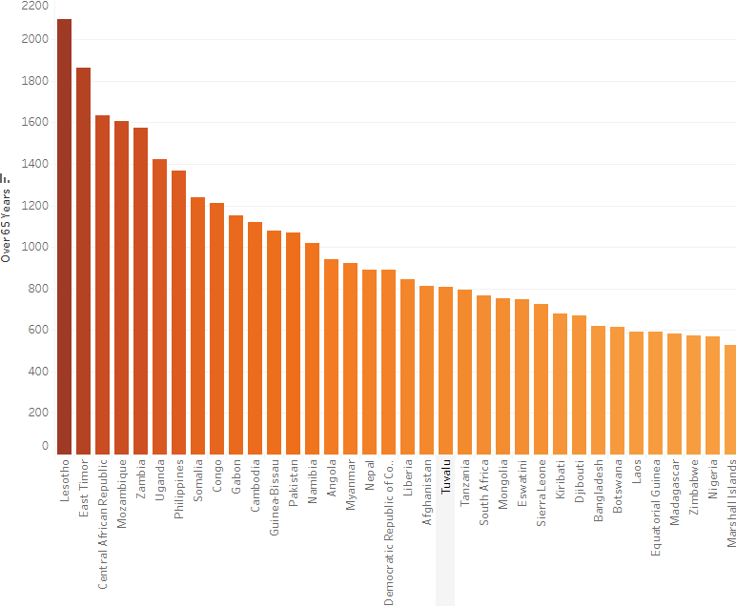

**5. TB Cases Attributed to Risk Factors (2022 Data)**

TB incidence is also influenced by various risk factors, as shown below:

| **Risk Factor** | **Estimated TB Cases** |
| --- | --- |
| **Malnourishment** | 2,187,940 |
| **HIV** | 895,726 |
| **Alcohol Use** | 732,120 |
| **Smoking** | 704,170 |
| **Diabetes** | 370,709 |

**Country-Specific Highlights:**

* **India**:
  + Highest TB burden from **alcohol use**: **248,000 cases**
  + TB cases linked to **malnourishment**: **744,000**
  + **Diabetes-attributed TB**: **102,000**

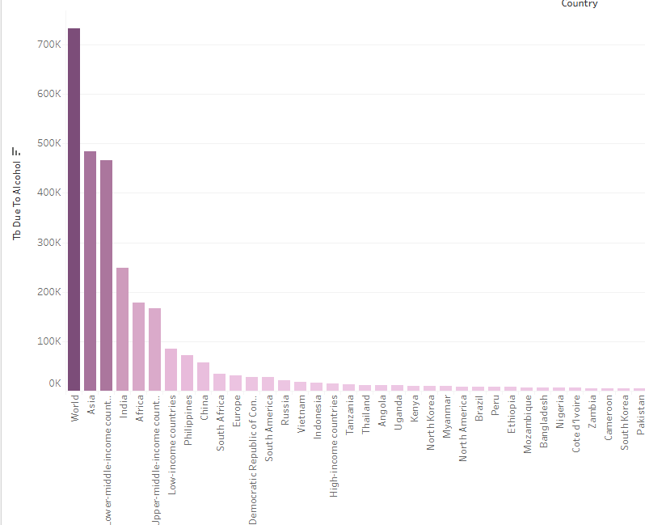

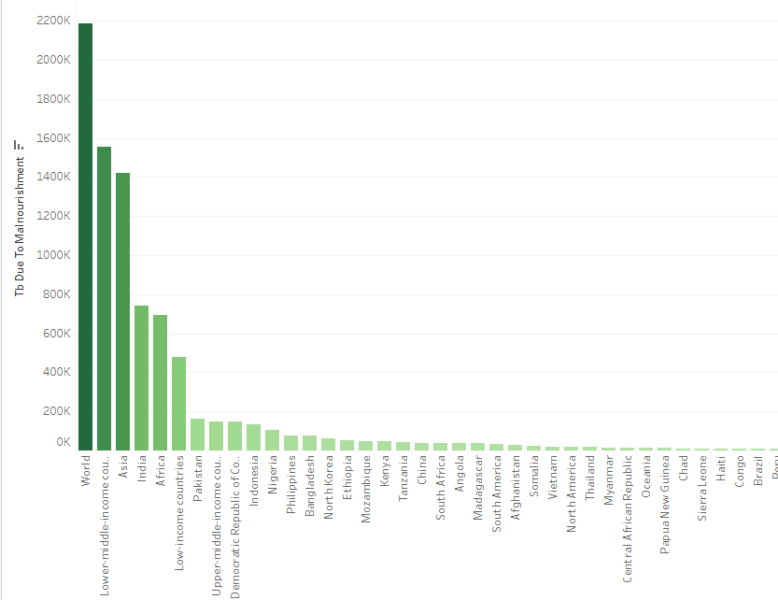

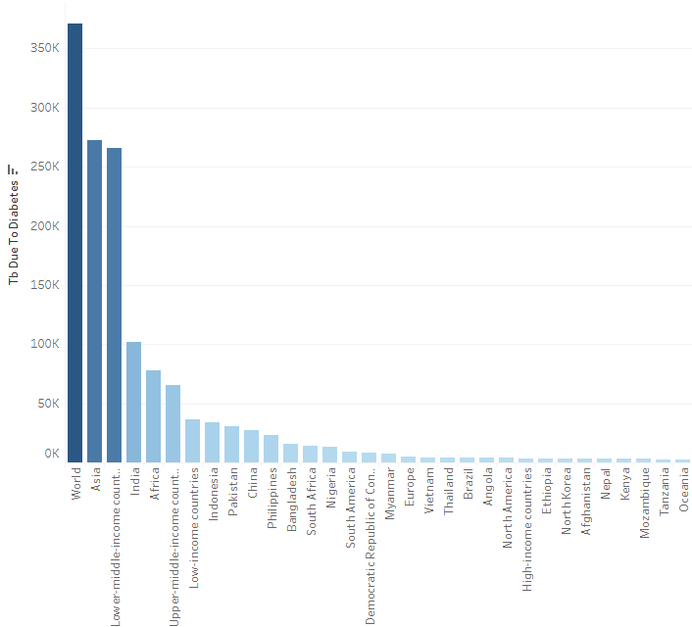

**South Africa**:

* Leads in **HIV-attributed TB**: **142,000 cases**
* While the 2nd Ranked Country is **India with 94,000 cases.**

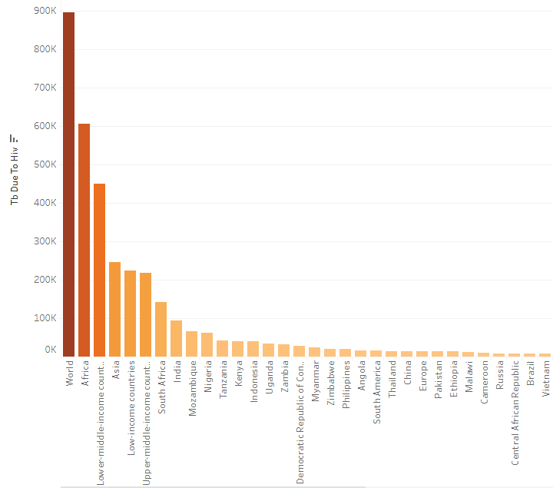

**Indonesia**:

* Highest TB cases due to **smoking**: **141,000**

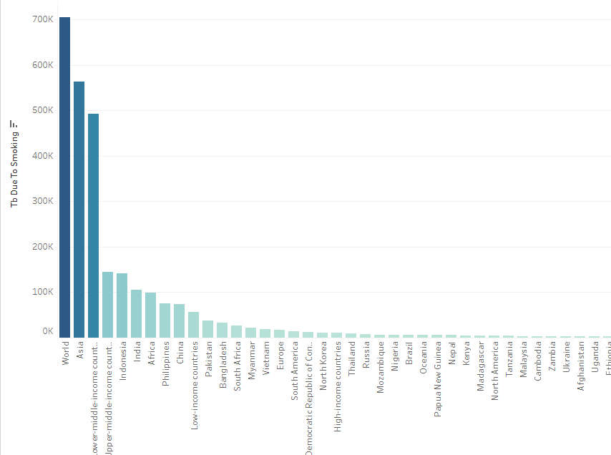

**Global Analysis of GDP, Health Expenditure, and TB Trends**

A macro-level analysis of tuberculosis (TB) in relation to economic indicators such as GDP per capita and health expenditure reveals encouraging global trends. Over the years 2000 to 2021, many countries have demonstrated an upward trajectory in health investment, particularly those with growing economies.

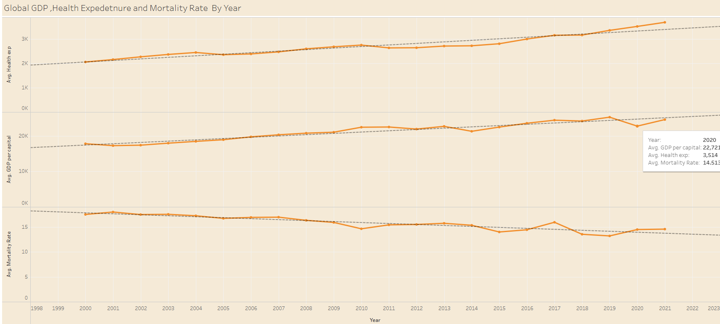

* **GDP and Health Expenditure Correlation:**  
  Countries with higher GDP per capita tend to allocate a greater share of resources to public health. This is evident in the steady rise of average health expenditure alongside increases in national income levels. Despite a noticeable dip in GDP per capita in 2020—primarily due to the global COVID-19 pandemic—trendlines suggest a strong recovery in subsequent years, accompanied by renewed commitment to healthcare spending.
* **Impact on Mortality and Treatment Success:**  
  There has been a measurable global decline in TB mortality rates over the two-decade span, as highlighted by declining trendlines. This improvement can be attributed to advancements in TB diagnostics, wider treatment availability, and strengthened public health systems in many low- and middle-income countries.

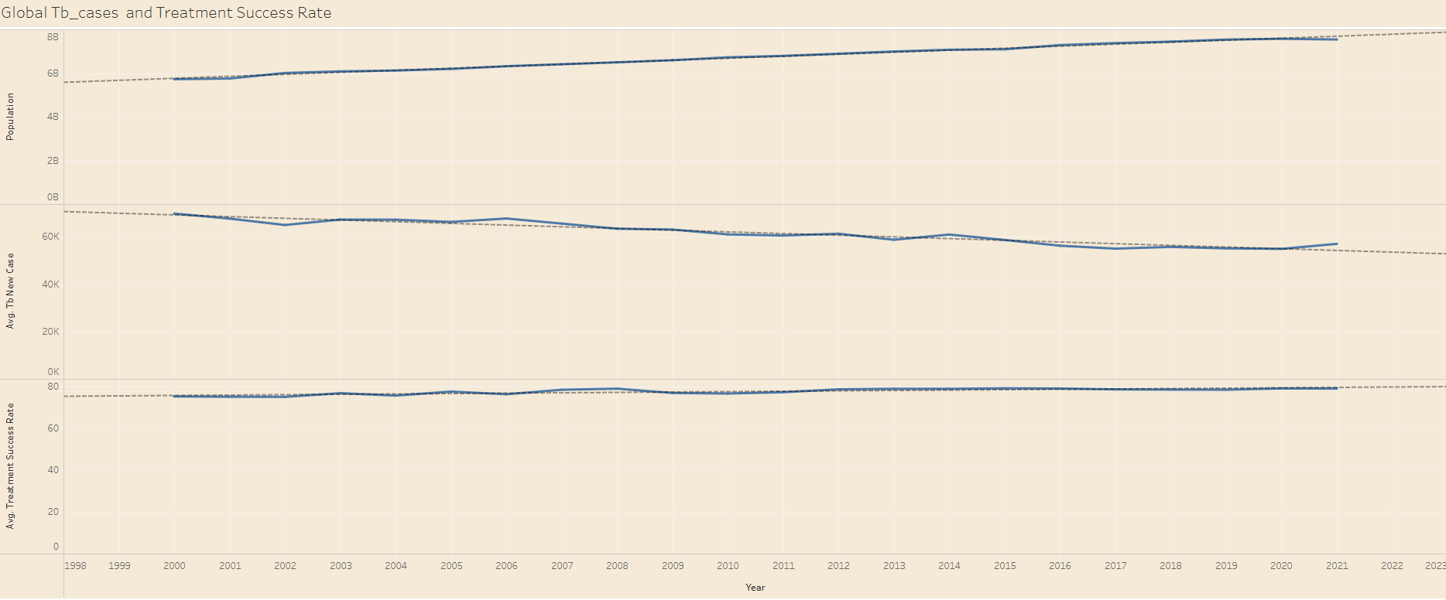

* **TB Burden vs. Treatment Outcomes:**  
  While global population continues to rise, data shows that treatment success rates have concurrently improved. This indicates that health systems are becoming more effective at reaching and managing TB patients, even under the strain of growing demand. For instance, India has progressed from a treatment success rate of 34% in 2000 to 78% in 2021, illustrating this positive direction.
* **New TB Case Reduction:**  
  Across most regions, there has been a steady reduction in the number of new TB cases reported annually. This signals enhanced preventive care, early detection, and increased public awareness—outcomes that are directly tied to better-funded health sectors.

**Summary Insight:**

This global perspective reinforces the importance of sustained economic development and health financing in combating TB. While disparities persist, especially in high-burden countries, the combined rise in GDP, healthcare investment, and public health effectiveness offers a hopeful trajectory. The data clearly suggests that with continued focus, international collaboration, and equitable access to treatment, a future with significantly reduced TB incidence and mortality is within reach.